**Grids ever fished:**

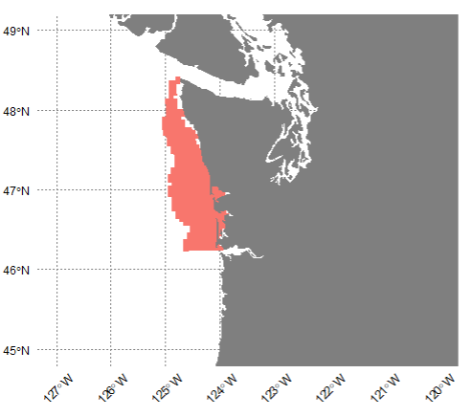

**Grids ever fished in May-Sep:**

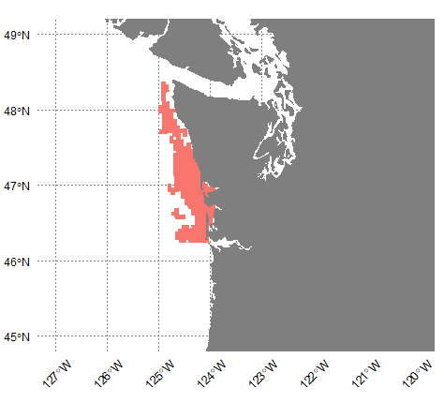

**Mean risk to whales in ‘grids ever fished in May-Sep’**

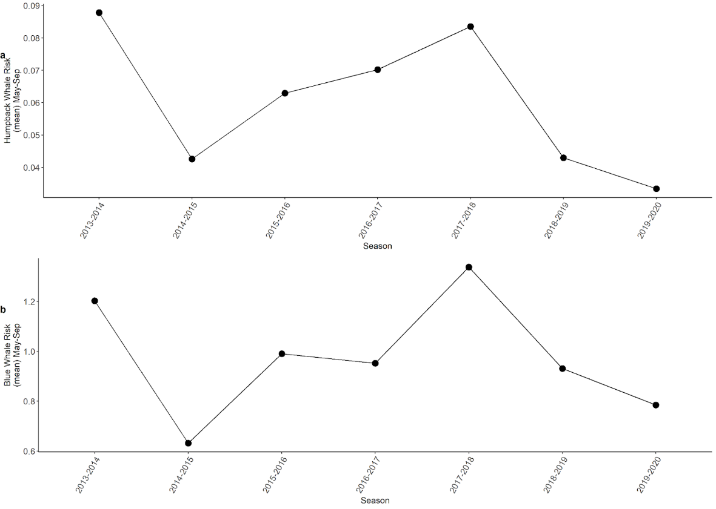

the drop from 2017-18 to 2018-19 or 2019-20 is large because 2017-18 was a 'high risk' season

drop from average risk across 'pre-regulation seasons' around 38%  and 51% for the last 2 seasons...